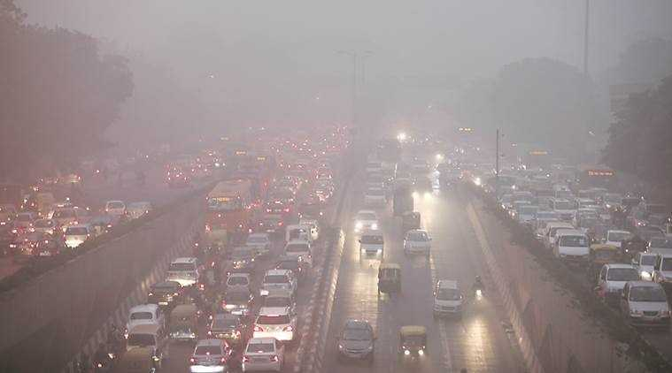

AIR QUALITY ANALYSIS & PREDICTION IN TAMILNADU

AIR QUALITY ANALYSIS AND PREDICTION IN TAMILNADU

**TEAM MEMBER**

* AU732521104045:SATHISH.D
* PHASE 2:SUBMISSION DOCUMENT

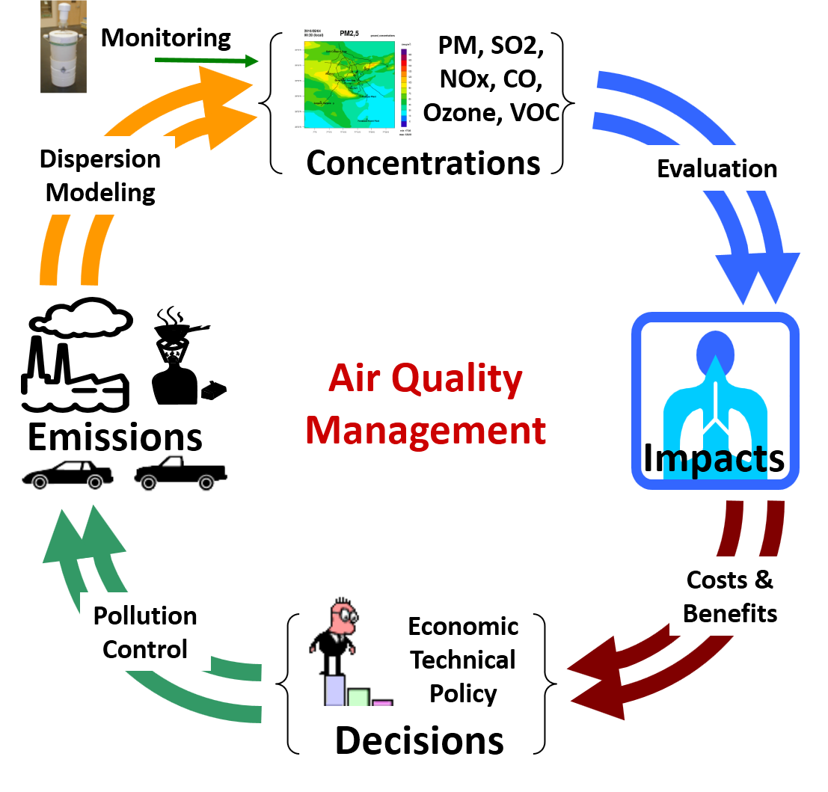

**INTRODUCTION**: Air quality refers to the condition or cleanliness of the

air we breathe it is typical assessed based on the concentration of various

pollutants and particular matter in the atmosphere.

**1.Ventilation**:

* Ventilation is the process of exchanging indoor air with fresh outdoor
* air. Proper ventilation helps remove indoor pollutants, control
* temperature and humidity, and ensure a healthy living or working
* environment. There are various ventilation systems, including natural
* ventilation, mechanical ventilation, and hybrid systems.

**2. Air Quality**:

* Maintaining good indoor air quality is essential for
* health and comfort. This includes managing pollutants like dust,
* allergens, chemicals, and odors. Air purifiers, filters, and proper building
* design can help improve air quality.

**3.** **Humidity Control**:

* Controlling humidity levels is important for
* comfort and health. High humidity can lead to mold growth, while low
* humidity can cause discomfort and health issues. Humidifiers and
* dehumidifiers are used to manage indoor humidity.

**4. Temperature Regulation**:

* Maintaining a comfortable temperature is
* vital. Heating, ventilation, and air conditioning (HVAC) systems are
* used to regulate indoor temperature. Energy-efficient systems are
* important for cost savings and environmental concerns.

**5. Air Distribution**:

* How air is distributed within a space is crucial.
* Ductwork, fans, and air registers ensure that conditioned air is delivered
* effectively to all areas. Proper air distribution helps avoid hot or cold
* spots.

**7. Monitoring and Control**:

* Modern air management systems often
* incorporate sensors and automation for real-time monitoring and control.
* This helps adapt to changing conditions and optimize air quality and
* energy use.

**8. Regulations and Standards**:

* A mandate specific air quality and management standards to ensure
* occupant health and safety.

**9. Maintenance**: Regular maintenance of ventilation systems, filters,

* and other components is crucial to ensure they operate effectively and
* efficiently air management is important in various settings, including
* homes, offices, hospitals, factories, and vehicles, to create a healthy and
* comfortable environment while optimizing energy use. The specific
* requirements and technologies used can vary depending on the context.

EXLPORATORY ANALYSIS:

* To begin the air exploratory analysis first import libraries and defining
* the air society managing things air quality restrictions are manage to
* develop the environmental area.
* DATA SOURCE:
* DATASET LINK: https://tn.data.gov.in/resource/location-wise-daily-

ambient-air-quality-tamil-nadu-year-2014

**SOURCE PROGRAM**:

# Import necessary libraries

import pandas as pd

from sklearn.model_selection import train_test_split

from sklearn.linear_model import LinearRegression

from sklearn.metrics import mean_squared_error

import matplotlib.pyplot as plt

# Load air quality data (sample data, you&#39;d need actual data)

data = pd.read_csv(&#39;air_quality_data.csv&#39;)

# Data preprocessing

# Assuming &#39;PM2.5&#39; is the target variable, and other columns are

features

X = data.drop(&#39;PM2.5&#39;, axis=1)

y = data[&#39;PM2.5&#39;]

# Split the data into training and testing sets

X_train, X_test, y_train, y_test = train_test_split(X, y, test_size=0.2,

random_state=42)

# Train a simple linear regression model

model = LinearRegression()

model.fit(X_train, y_train)

# Make predictions

y_pred = model.predict(X_test)

# Evaluate the model

mse = mean_squared_error(y_test, y_pred)

print(f&quot;Mean Squared Error: {mse}&quot;)

# Plot the actual vs. predicted values

plt.scatter(y_test, y_pred)

plt.xlabel(&#39;Actual PM2.5&#39;)

plt.ylabel(&#39;Predicted PM2.5&#39;)

plt.title(&#39;Actual vs. Predicted PM2.5&#39;)

plt.show()

**conclusion**:

* In conclusion, air quality analysis and prediction are crucial for
* monitoring and managing air pollution, which has significant
* environmental and public health implications. This process involves
* collecting, processing, and modeling air quality data to provide valuable